**Inter Disciplinary Project**

**Framework for Efficient Analysis of Operational Research Algorithms**

FEAORA

|  |  |
| --- | --- |
| **Examiner:** | Prof. Dr. Stefan Minner  Chair for Logistic and Supply Chain Management  TUM School of Management  Technische Universität München |
|  |  |
| **Supervisor:** | M.Sc. Miray Közen |
|  |  |
| **Study Course:** | Master of Science in Informatics |
|  |  |
| **Submitted by:** | |  |  | | --- | --- | | Anshul Vij | Akshit Malhotra | | Felsennelkenanger 7 | Felsennelkenanger 15 | | 80937 München | 80937 München | | Matrikel-Nr. 03645942 | Matrikel-Nr. 03645940 | |
|  |  |
| **Submitted on:** | 12.11.2015 |

Abstract

Operational Research deals with numerous problems of varied nature. Few common problems that are discussed and studied are Traveling Salesman Problem (TSP), Transportation Problems, Maximization and Minimization Problem, Shortest Path Problem, Vehicle Routing Problem, Arc Routing Problem, Warehouse Operations, Intermodal Transportation, Capacity Planning, Inventory Planning, etc. A lot of these problems are NP-Hard problem which means to find the optimum solutions using brute force will not work or be an efficient solution or will take years to complete. There is tremendous scope of research in the area of developing new and more efficient algorithms to tackle these problems. But to realize an algorithm and test or benchmark it is a tough job if one had to enter the input criteria or configurations manually for each iteration of the algorithm. There is an urgent requirement to develop frameworks and tools that can reduce this load from the end-user, analyst, modeler, mathematical-scientist. Also to check for results and outputs using manual data parsing and conversion to graphical visualization requires a lot of effort and involves repetitive tasks which may cause human errors which lead to absurd results and false rejection/acceptance of an algorithm.

This project is strictly aimed at reducing this manual effort by the algorithm designer, analyst, mathematical scientist or end-user. It provides efficient and easy way to model a number of input combinations and add randomized data using various probability distributions. The user does not have to enter them manually or need do additional programming which is not necessary part of his/her implementation. Also the OR-algorithm designer or programmer has the freedom to use '‘Mosel’' modeling language which is extensively used for OR algorithms and is a standard for designing OR-algorithms.

Apart from reducing effort to manually input data for every iteration FEAORA framework and tool also allows the user to quickly generate a wide range of output visualizations ranging from various charts to live Google Maps. These visualization options make it very easy for even novice programmer to quickly generate a lot of visualizations that can help in early and quick detection of a problem in algorithm or to understand the results more easily. As rightly said by someone that a picture is worth a thousand words, seeing the charts, graphs and being able to filter the results from another simple tool such as spreadsheet viewer make the implemented framework and tool very easy to learn and use.

# Table of Contents

Table of Contents iii

List of Figures v

List of Abbreviations vi

1 Introduction 1

1.1 Problem Definition and Objective 1

1.2 Outline 3

2 Review of Literature and Research 4

2.1 OREX-J 4

2.2 Evaluation of OREX-J 5

2.2.1 Effort Required 5

2.2.2 Benefits 6

2.2.3 Limitations: 7

3 Methodology 9

3.1 Approach 9

3.2 Overview 9

3.3 Model Guidelines 10

3.4 Application Phases 11

3.4.1 Model Importing 11

3.4.2 Input Modeling 12

3.4.3 Test Instance Generation 13

3.4.4 Probability Distributions 14

3.4.4.1 Exponential 14

3.4.4.2 Gamma 15

3.4.4.3 Normal 16

3.4.4.4 Logistic 17

3.4.4.5 Uniform 19

3.4.5 Step Distribution 20

3.4.6 Model Execution and Output Saving 21

3.4.6.1 Model Execution 21

3.4.6.2 Output Saving 21

3.4.7 Chart Visualization Modeling 22

3.4.8 Map Visualization Modeling 23

4 Results 26

4.1 Sample ‘Mosel’ Code 26

4.2 Sample Input Configuration 27

4.3 Output analysis 27

4.4 Sample Chart Visualization Configuration 28

4.5 Sample Map Visualization Configuration 30

5 Conclusion 33

5.1 Limitations of the FEAORA framework 33

5.2 Further Research and Improvement 34

6 Bibliography 35

Ehrenwörtliche Erklärung 36

# List of Figures

Figure 1: Flowchart for the FEAORA framework 2

Figure 2: Architecture of an OREX-J implementation for an OR algorithm 5

Figure 3: Various interfaces/classes that are required to be implemented by the user 7

Figure 4: Inheritance of probability distribution classes 9

Figure 5: Application components of FEAORA framework 10

Figure 6 : Model Importing Logic of FEAORA framework 12

Figure 7: Import model screen of FEAORA framework 12

Figure 8: Input modeling screen of the FEAORA framework 13

Figure 9: Exponential distribution sample curve 15

Figure 10: Gamma distribution sample curve 16

Figure 11: Normal distribution sample curve 17

Figure 12: Logistic distribution sample curve 18

Figure 13: Uniform distribution sample curve 19

Figure 14: Normal distribution sample curve: The chart shows the sampled value after each sample count on x-axis 20

Figure 15: Flow chart for ‘Mosel’ Parser and Executor 22

Figure 16: Flow chart for chart visualization 23

Figure 17: Flow chart for Google map visualization 24

Figure 18: Google map visualization with points only map type 25

Figure 19: Google map visualization with points with paths map type 25

Figure 20: Google map visualization with points with directed paths map type 25

Figure 21: Sample input configuration screen 27

Figure 22: Output saved in excel format 27

Figure 23: Filtering of the result rows using excel filter option 28

Figure 24: Sample chart visualization configuration 28

Figure 25: Sample line chart visualization 28

Figure 26: Scatter chart visualization 29

Figure 27: Bar chart visualization 29

Figure 28: Pie chart visualization 29

Figure 29: Sample map visualization configuration 30

Figure 30: Points only map output with show all nodes option checked 30

Figure 31: Points only map with filtered points using a 1-D node condition array 31

Figure 32: Points with path map with filtered edge using 2-D edge condition array 31

Figure 33: Points with directed paths with filtered edge using 2-D edge condition array 32

# List of Abbreviations

|  |  |  |  |
| --- | --- | --- | --- |
|  |  |  | |
| IDP |  | Inter-disciplinary Project | |
| OR |  | Operation Research |
| FEAORA |  | Framework for Efficient Analysis of OR Algorithms |
| TSP |  | Traveling Salesman Problem |
| GUI |  | Graphical User Interface |
| CSV  API |  | Comma Separated Value  Application Program Interface |
|  |  |  |
|  |  |  | |
|  |  |  | |
|  |  |  | |
|  |  |  | |

|  |  |  |
| --- | --- | --- |
|  |  |  |

# Introduction

## Problem Definition and Objective

This IDP is themed on providing a framework for assisting OR scientists and programmers to efficiently analyze the ability of their algorithms. They should focus on algorithm performance and correctness rather than manually making hundreds of random test cases, running the algorithm manually for each test case input and then manually making visualizations for the results of those algorithms.

This IDP project focuses on four main goals:

1. Input modeling for OR algorithm
2. Execution of OR algorithm with generated input parameters
3. Saving the results of OR algorithm execution into excel format
4. Output modeling using chart visualizations and Google Maps

The main objective of this IDP is to conceptualize such a framework and provide an efficient working tool that can be used to realize the conceptual model of the framework. This framework aims to provide adapter between the OR algorithmic model and analysis test bench that runs the modelled algorithm with a number of input configurations/settings/variables and displays the result in visually appealing methods such as of charts and maps.

Following are the requirements for the FEAORA framework:

1. Provide input modeling that allows user to select input variable by a manual fixed entry, entry from external file, sequential entry for each iteration and randomized entry based on popular probability distribution. (ReqA)
2. Importing OR algorithm build in ‘‘Mosel’’ language[6] without need of programming any adapter in any other language. (ReqB)
3. Generating combinations of input data set instances based on all variables whose values are allotted in step(sequential) distributions. (ReqC)
4. Providing a way to have each combination generated in ReqC as many times as required with other randomized variables changing for every iteration. (ReqD)
5. Saving the OR algorithm output in commonly used excel format for every iteration in a same file with input data values for each iteration. (ReqE)
6. Provide some basic chart visualizations for the output data and automatically generating chart and saving in output excel file. (ReqF)
7. Provide Google Map visualization for problems that deal with locations and transport routes based on output variables. (ReqG)
8. Loading of saved input configuration and re-execution of previously saved input configuration and allowing modification for input and output visualization settings. (ReqH)

A typical flowchart for the entire framework is shown below:

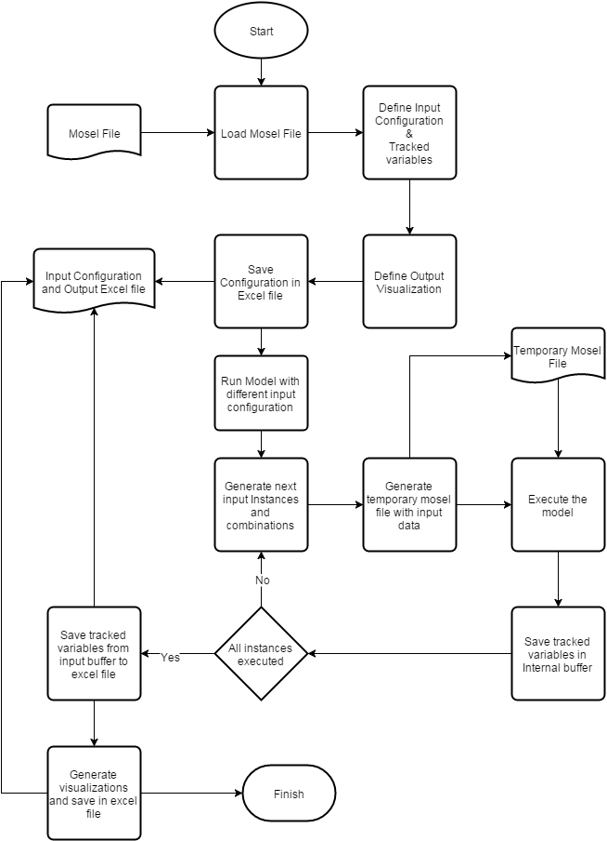

Figure 1: Flowchart for the FEAORA framework

## Outline

This IDP document is structured into six chapters. Chapter 1 gives an overview of the FEAORA framework, requirements and goals. Chapter 2 provides a survey of the literature on which this project is based. This includes literature on an OREX-J framework that requires a lot of Java programming by the OR scientist to plug the algorithm with the testing/analysis bench provided by the framework. The pros and cons of OREX-J framework will be discussed here and motivation to make FEAORA framework is also established.

In Chapter 3 the objective of the project is defined, and the methodology that is used to realize this objective is outlined. The methods and tools used for creating the working prototype of this framework are also discussed. Finally, the general windows and user interface is discussed and a detailed explanation about the usage of the framework and tool is presented.

In Chapter 4, the samples and examples of the usage are described with the help of screenshots of the application framework and result analysis of charts and maps. Chapter 5 summarizes the conclusions drawn from this study. In Chapter 6, the limitations of this study are explained, and ideas for further research and improvement are presented.

# Review of Literature and Research

This section deals with the review of literature that was used to conceptualize the model of this framework and understand the current state of the art related to efficient analysis of OR algorithms. The IDP was initially inspired by the OREX-J paper[1] which describe first such open source framework that allows OR scientists to plug in their algorithms to a test bench and compare different variations of algorithms on same set of data.

## OREX-J

The Operations Research EXperiment Framework for Java (OREX-J) [1] is an object-oriented software framework that helps users to design, implement and conduct computational experiments for the analysis of optimization algorithms. As it was designed in a generic way using object-oriented programming and design patterns, it is not limited to a specific class of optimization problems and algorithms.

The purpose of the framework is to reduce the amount of manual labor required for conducting and evaluating computational experiments: OREX-J provides a generic, extensible data model for storing detailed data on an experimental design and its results. Those data can include algorithm parameters, test instance generator settings, the instances themselves, run-times, algorithm logs, solution properties, etc. All data are automatically saved in a relational database MySQL [cite: (<http://www.mysql.com/>)] by means of the object-relational mapping library Hibernate [cite:(<http://www.hibernate.org/>)]. This simplifies the task of analyzing computational results, as even complex analyses can be performed using comparatively simple Structured Query Language (SQL) queries. Also, OREX-J simplifies the comparison of algorithms developed by different researchers: Instead of integrating other researcher’s algorithms into proprietary test beds, researchers could use OREX-J as a common experiment framework.

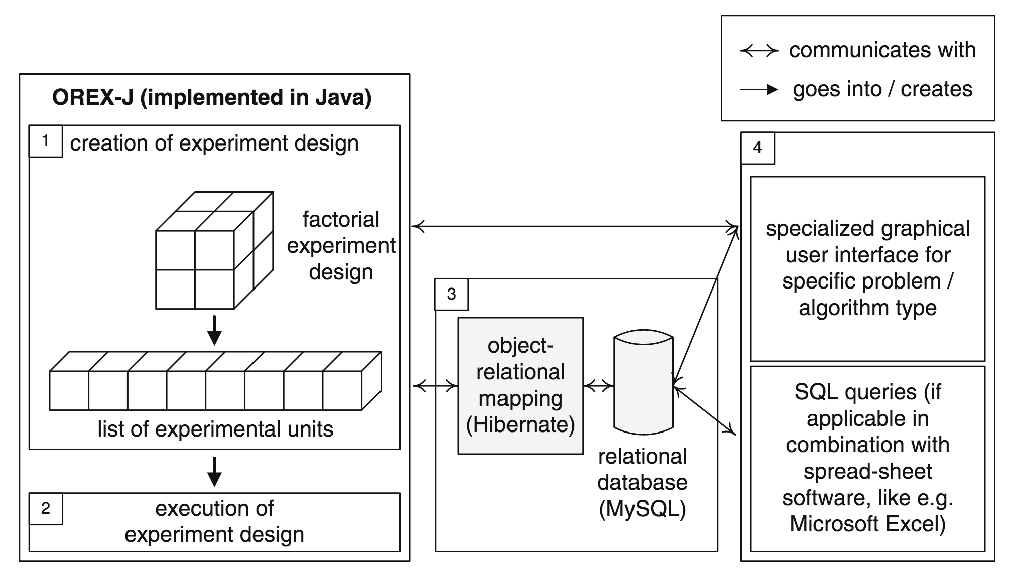

Figure 2: Architecture of an OREX-J implementation for an OR algorithm

## Evaluation of OREX-J

We evaluated OREX-J based on the amount of effort required to use it or plug your model into its analysis framework, the benefits it has over conventional manual configuration of different test instances and manual sorting/analysis of the results, and finally its limitations that motivated us to develop a new framework for experimental analysis of Operational Research algorithms.

### Effort Required

In order to realize an Operational Research algorithm in OREX-J we have to somehow make it available to Java via some adapter or we need the implementation purely in Java. For this task we need to formulate and structure the algorithm using OREX-J APIs and callback methods. Callback methods are like listener interfaces which are invoked when OREX-J has to send some message to the Operational Research algorithm components. Some examples are like to inform the user about the completion of loading, test instance generation and completion of execution of algorithm. While APIs are the direct interface between the OR algorithm and the OREX-J components that can be used by the OR scientist or programmer to invoke various functions of OREX-J framework. This requires some additional effort for the programmer that needs to be done in Java programming language which is a very popular language for computer scientists but is considered to be a challenge for non-computer scientists.

Also to generate test instances OREX-J provides no direct APIs but a the user or the OR scientist have to implement some interfaces so that he/she can generate the test instances based on randomized inputs. For example to use probability distributions to fill an array that contains the demand for a particular item over a period of 30 days or say for 12 months. OR scientists often use probability distributions for filling of such arrays or values. These distributions include Gamma, Normal, Binomial, Logistic, Exponential, Geometric, etc. In case of OREX-J user has to program the generation of test values based on these distributions. There is a freedom that programmer can use any other library in his program and generate such random values.

Once the task of generation of input data set is completed and combined with the loading and execution APIs and callbacks the user can see the results using external SQL database viewers and make queries in SQL to compare of filter some values. This again requires some knowledge of SQL which is often a standard knowledge set of a computer scientist but typically not a standard for OR scientist. But the learning curve for SQL language just to query the database is not so steep as the curve to learn Java programming language.

As for visualization of the output user still need to code that using some basic visualizations APIs provided by OREX-J or user can choose his own visualization libraries that are available in Java but again this requires coding in Java which is serious overhead for a OR scientist who is not specialized in using Java programming language.

### Benefits

The benefits of OREX-J over conventional manual configuration and repetitive execution of OR algorithms certainly lies in automating this task and reducing manual entry of input data values and providing a common data base to store results from all executions even for different algorithms.

OREX-J also provides the solution as an open source framework that can be used with freely available Java programming language and there are also free Integrated Development Editors that support Java language. One such popular IDE is Eclipse.

Another benefit of OREX-J is comparison of different algorithm’s performance and accuracy using SQL query.

### Limitations:

OREX-J was designed and implemented keeping in mind a lot of design patterns and software testing concepts but never the less every solution should be studied for its usefulness in real life scenarios. As per the discussion with the OR scientists supervising this project it was clear that they generally never had to deal with programming in Java language. It is only popular amongst computer scientists or software programmers. This was a key loop hole that restricts the usage of OREX-J by a number of OR scientists and mathematicians who have no or little knowledge of Java.

Apart from learning Java the OR scientist also needs to understand various abstract classes and API’s provided by OREX-J and implement a lot of code in a number of different files. Figure 3 shows a number of files that needs to be implemented and coded by the OR scientist before he can begin with running a single test instance. The FEAORA framework is critically dedicated to avoid this demanding task as user virtually doesn’t have to program anything special to bind his/her algorithm to the framework. User just provides a model file in a popular language amongst OR scientists, “‘Mosel’” language[6] which is used by FICO Xpress[7] software. FICO Xpress is the software of choice for many OR scientists and also provides special licenses for academic use to university chairs across the world[7].

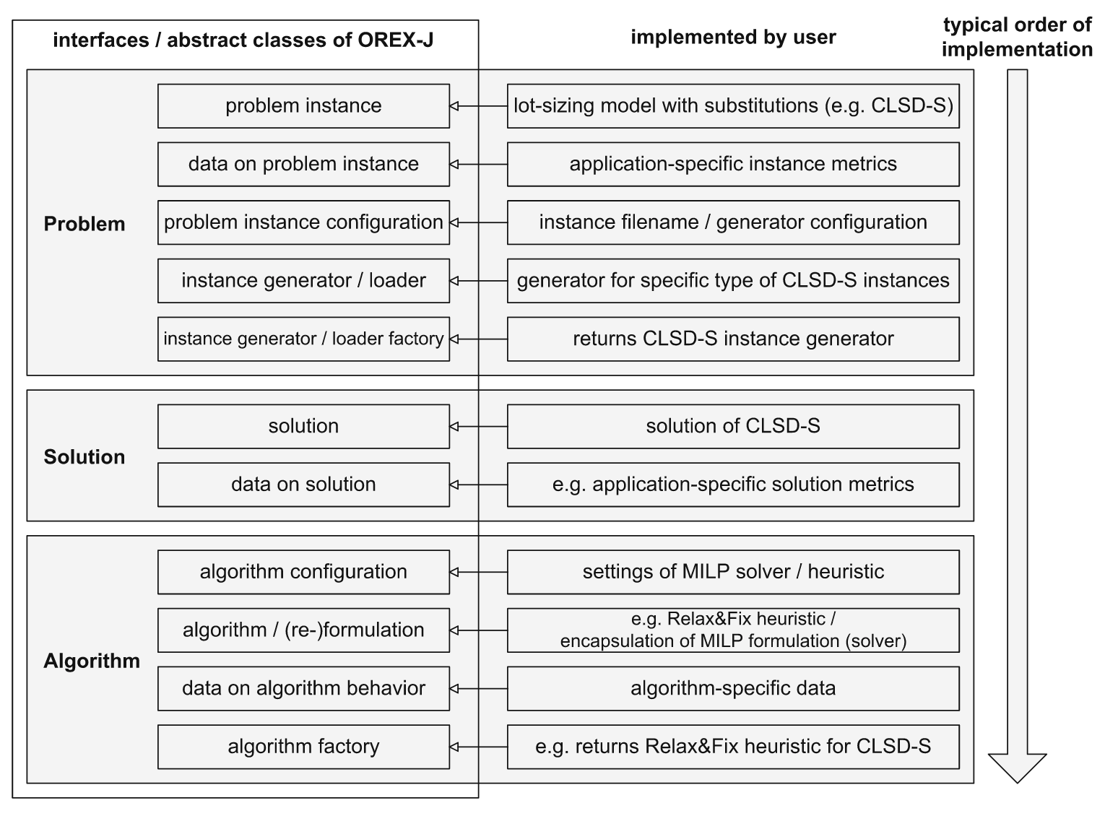

Figure 3: Various interfaces/classes that are required to be implemented by the user

Also for realizing output visualizations again the OREX-J user has to program a series of files dedicated for each visualization which is again a tedious job. The FEAORA framework eliminates this overhead by simply providing user options to select various charts from a graphical user interface and specifying variables for X and Y axis or specify just the variables containing location names and decision variable name that determines that a location is selected or not.

# Methodology

This section describes in detail the concept of FEAORA framework and associated GUI tool design and implementation.

## Approach

The application is designed keeping in mind Object Oriented design patterns. The probability distributions are also implemented using Apache’s Distribution APIs[2]. Furthermore even the custom implementation of step distribution follows the same principle and inherits apaches interface for distribution so that common method ‘sample()’ can be used for anywhere to generate a sampled value out of the distribution.

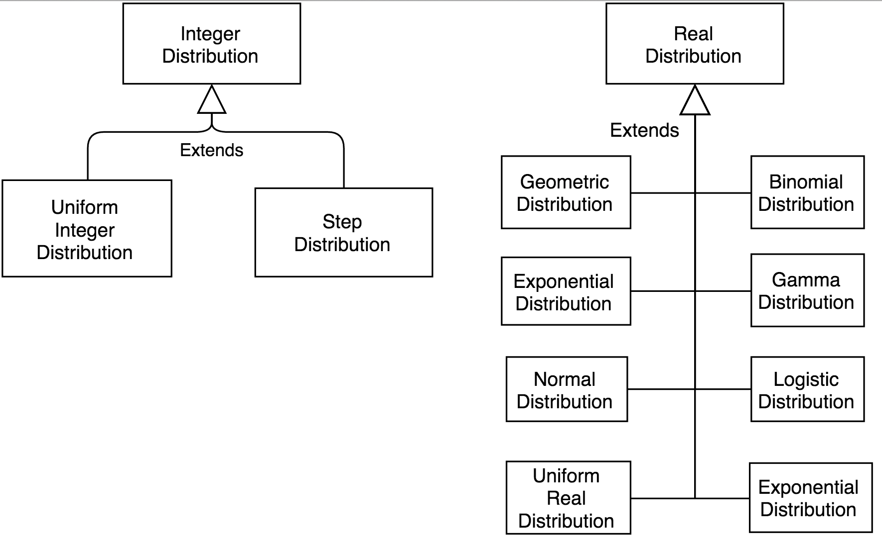

Figure 4: Inheritance of probability distribution classes

## Overview

The application allows user to do 5 main tasks:

* Import a ‘‘Mosel’’ model
* Input modeling for test instance generation
* Execute the test instances and save result to solution file
* Chart visualization modeling and saving to solution file
* Map visualization modeling and viewing in external browser

Figure 4 depicts the relationship between various application components of FEAORA framework.

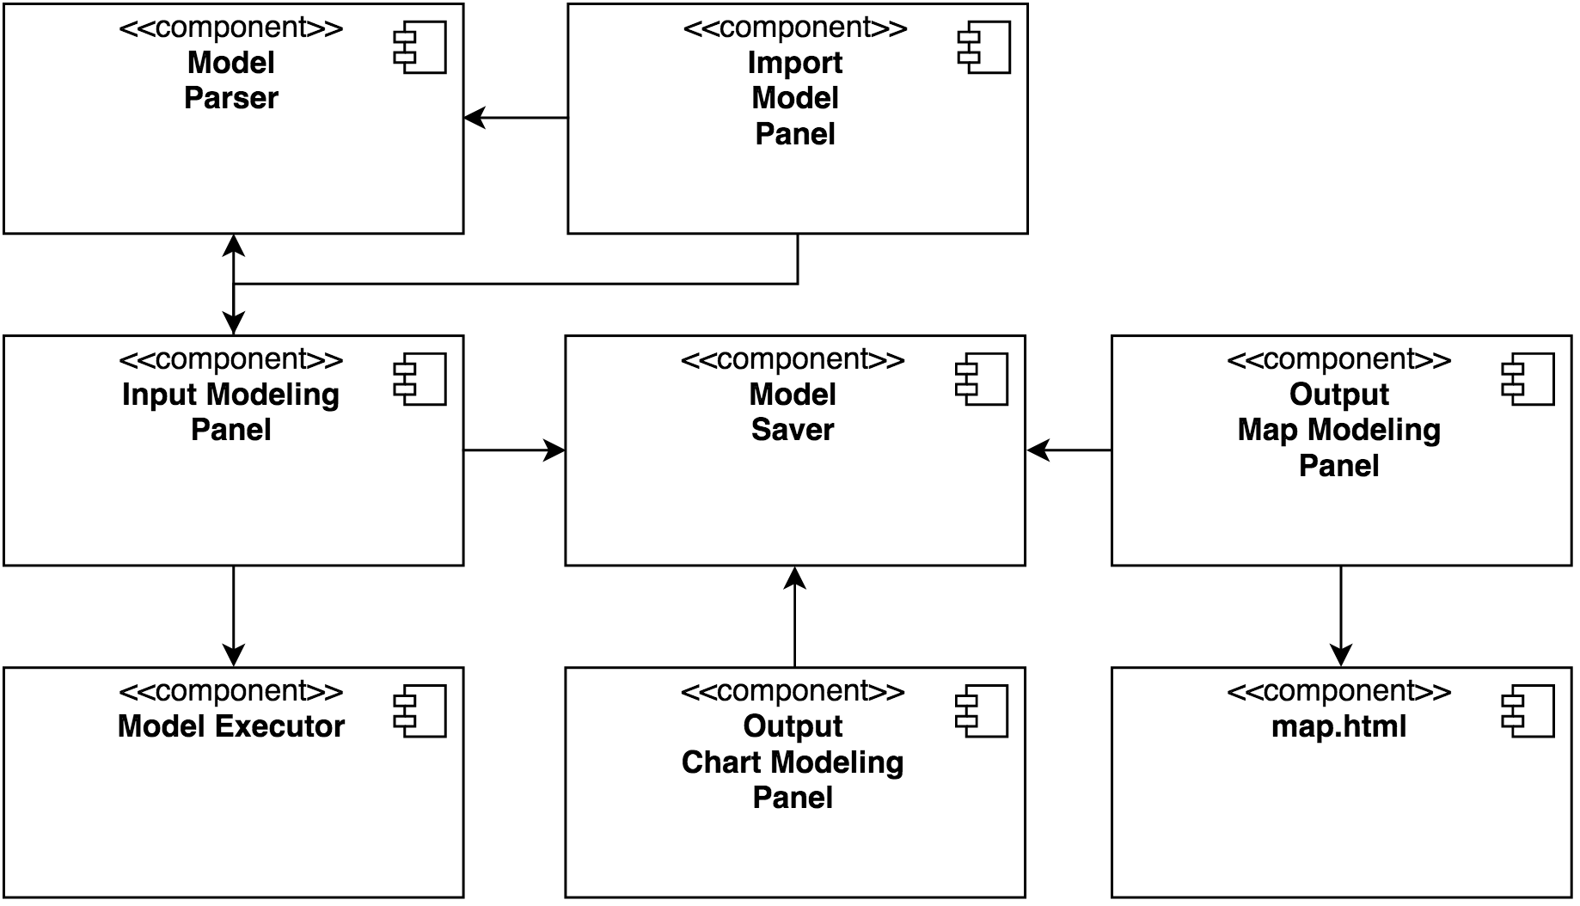

Figure 5: Application components of FEAORA framework

## Model Guidelines

This section describes the guidelines for any importable ‘‘Mosel’’ file[6][7]. In order to comply with the FEAORA framework there is no additional coding is required, instead it is advised just to declare the variables required to be input modeled by the framework in the declaration blocks. FEAORA framework only parse the parameters and variable declaration sections of a ‘‘Mosel’’ file. Other internal variables are not touched at all. If user requires more variables to be tracked by the FEAORA framework then they should be first declared in the variable declaration block.

Model Parser built for FEAORA framework forms the basis for the things being structured at User Interface level. The parser is mainly working itself around the base ‘Mosel’ file which the user firstly imported, mainly with respect to understanding the syntax and style of coding in ‘Mosel’.

Before explaining the model further, there are certain terminologies that needs to be put in place in order to fully understand its functionality. We use the term “Symbol” to denote both the variables written under “Parameters” and “Declarations” block in the ‘Mosel’ file. Parameters block in the ‘Mosel’ are basically all the constants that are being used for a particular problem. And inside the Declarations block, all the variables are declared along with their types, and this could also include constants. We also have “Initialization” blocks that are used for importing values of symbols from external file source. An example of all these blocks are given in following ‘‘Mosel’’ code:

parameters

LIMIT = 100

NMAX = 5

CMAX = 10

end-parameters

declarations

a: set of real

b: integer

gamma: real

success: boolean

end-declarations

initialization from “abc.txt”

a as “anotherNameForA”

b as “anotherNameForB”

end-initialization

## Application Phases

### Model Importing

The ‘‘Mosel’’ model adapted to FEAORA framework can be easily imported on the main screen of the application by just browsing in the file system. Model importing logic is shown in figure 6. The importer starts with preprocessing stage, where it does the sanity checking of the ‘Mosel’ file given by the user and thereby verifies for any compilation errors. If there are any errors, importer will straight away notify the user with clear descriptions of all the errors. This will help the user in checking the ‘Mosel’ file and taking the corrective measures. Upon successful compilation, Model Importer starts the first round of parsing by looking under mainly two blocks of the ‘Mosel’ file, which are “Parameters” and “Declarations” block. The purpose here is to extract all the symbols that are defined/declared in these two blocks. It starts by tokenizing line by line to get all the relevant information of symbols like name and type. These details are then used by Symbol Parsing where a meta data is formed for all the symbols. Finally a list of all symbols are formed for GUI updating. This way it collects all the symbols encountered and gives back this list to GUI. It is important to note here that the ‘Mosel’ code is not run yet and is only compiled till this point.

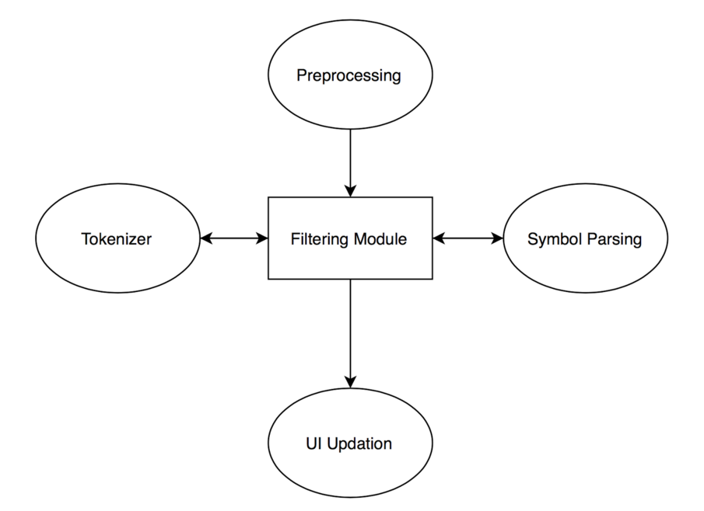

Figure 6 : Model Importing Logic of FEAORA framework

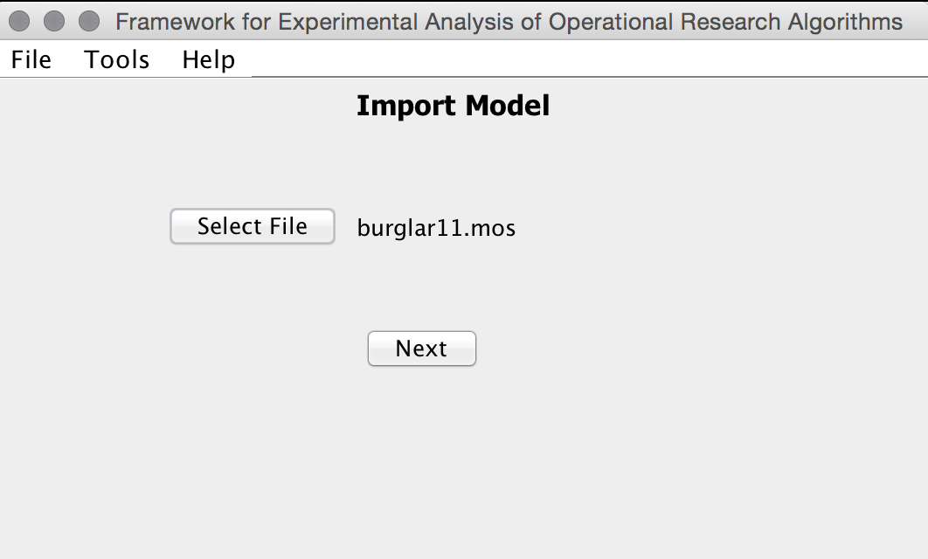

Figure 7: Import model screen of FEAORA framework

### Input Modeling

Input modeling is the very first goal of FEAORA framework. The variables mentioned in the parameters and declaration block of ‘‘Mosel’’ file are shown in a table format with associated data type and default values if assigned in ‘‘Mosel’’ file. Each of the variables except the linear constraint denoted by ‘linctr’ data type and mathematical programming variable denoted by ‘mpvar’ are not editable as these are either decision variables or optimizing constraints for a OR algorithm defined in the imported ‘‘Mosel’’ file. Other variables are modifiable by the user.

Each variable can be initialized in a number of ways:

1. **Default:** The value given in the ‘‘Mosel’’ by the user.
2. **Manual:** User manually enters the value of variable in the value column.
3. **External:** User enters the external file name such as a data file with variable initializations as used in ‘‘Mosel’’ normally or an excel file along with the range value filled in the range column. Range value includes the sheet name and range in the same format as done in ‘‘Mosel’’ language.
4. **Randomized:** It allows user to fill the variable by many probability distributions. For every instance of input data these variables will be initialized using this randomization probability distribution. More information on probability distribution is provided later.
5. **Step:** It allows user to fill the variable by sequentially assigning value for each instance of input values. User can define a min and max value along with step information. If step information is not provided it is assumed to be 1. Only integer steps and values are allowed for step distribution.

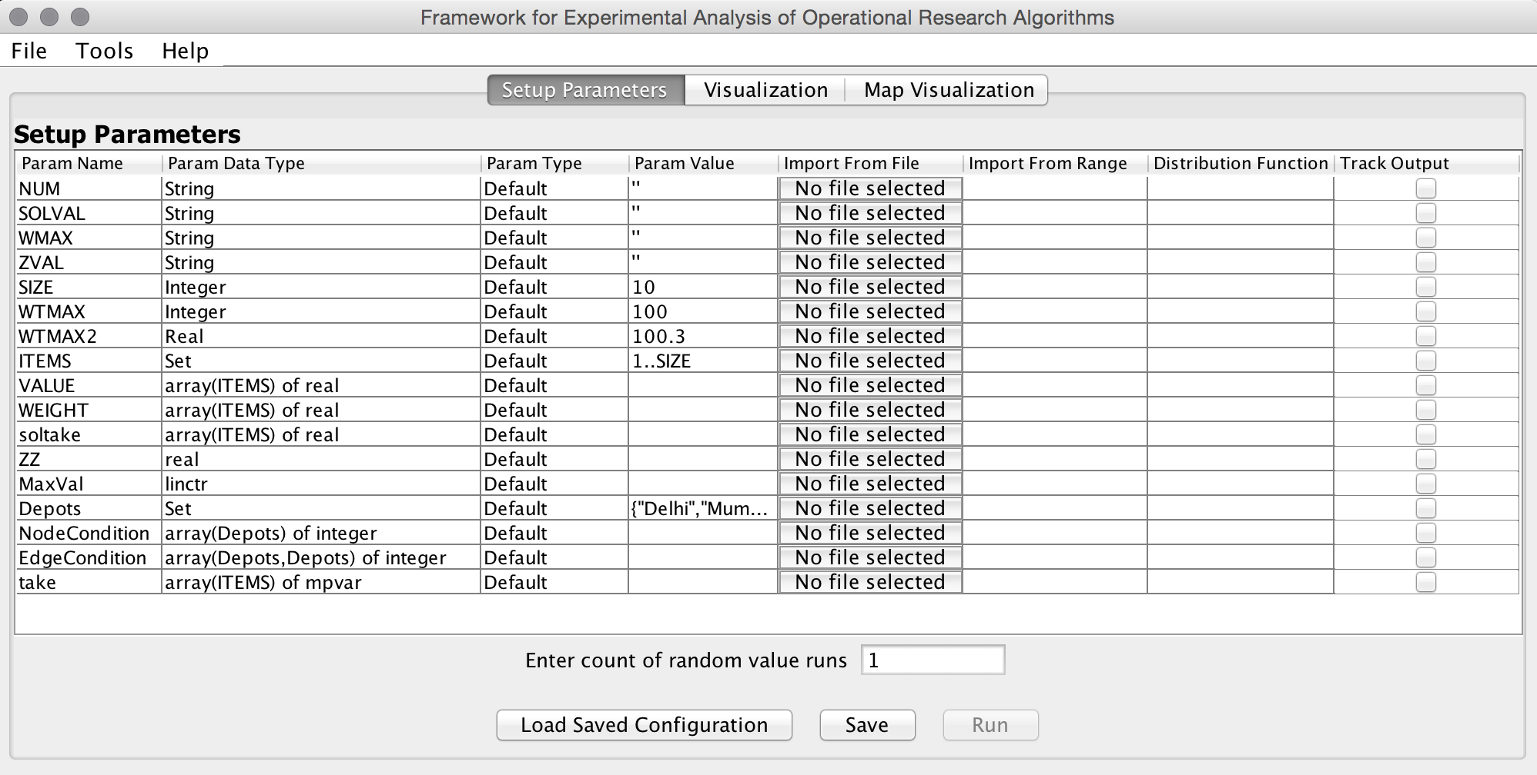

Figure 8: Input modeling screen of the FEAORA framework

|  |  |
| --- | --- |
|  |  |

### Test Instance Generation

Once the modeling configuration is completed and saved by user, the user can start executing the model with different test input instances by clicking the run button.

The number of instances depend on the number of steps for different step variables and effectively equal to the product of step count for all the variables which as step distributed multiplied by the ‘count random value runs’ . For every random value run each combination of step variables and randomized variables is run with different values for randomized variables.

For example, if there are 3 variables A defined as step(1,3), B defined as step(1,10,2) and C defined as uniform(10,20) and count of random value runs is 3. Then there are a total of 3x5x3 = 45 number of test instances for this configuration.

Variables defined as custom or external always take same value for each instance.

### Probability Distributions

Following probability distributions are supported by FEAORA framework. They documentation and implementation is similar to another popular simulation tool AnyLogic’s probability distributions[5].

#### Exponential

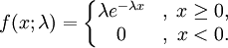

The Exponential distribution is a continuous distribution bounded on the lower side. It’s shape is always the same, starting at a finite value at the minimum and continuously decreasing at larger x. The Exponential distribution decreases rapidly for increasing x.

The Exponential distribution is frequently used to represent the time between random occurrences, such as the time between arrivals at a specific location in a queuing model or the time between failures in reliability models. It has also been used to represent the services times of a specific operation. Further, it serves as an explicit manner in which the time dependence on noise may be treated. As such, these models are making explicit use of the lack of history dependence of the exponential distribution; it has the same set of probabilities when shifted in time. Even when Exponential models are known to be inadequate to describe the situation, their mathematical tractability provides a good starting point.

**Sample:** lambda=1;

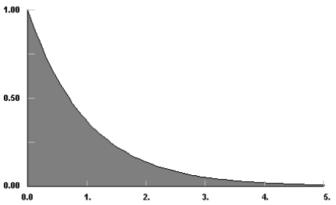

Figure 9: Exponential distribution sample curve

**Usage:**

* exponential(lambda)
* exponential(): Assumes lambda = 1

#### Gamma

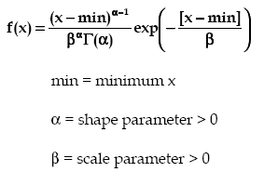

The Gamma distribution is a continuous distribution bounded at the lower side. It has three distinct regions. For alpha=1, beta=1/lambda the Gamma distribution reduces to the exponential (lambda) distribution, starting at a finite value at minimum x and decreasing monotonically thereafter. For alpha<1, the Gamma distribution tends to infinity at minimum x and decreases monotonically for increasing x. For alpha>1, the Gamma distribution is 0 at minimum x, peaks at a value that depends on both alpha and beta, decreasing monotonically thereafter. If alpha is restricted to positive integers, the Gamma distribution is reduced to the Erlang distribution. The Gamma distribution has been used to represent lifetimes, lead times, personal income data, a population about a stable equilibrium, inter-arrival times, and service times. In particular, it can represent lifetime with redundancy.

Note that in FEAORA implementation min is always 0.  
  
**Sample:** gamma(1,2)

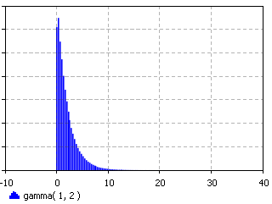

Figure 10: Gamma distribution sample curve

**Usage:**

* gamma(alpha, beta)

#### Normal

|  |  |
| --- | --- |
| *Density* | http://www.anylogic.com/anylogic/help/topic/com.xj.anylogic.help/html/functions/images/normal_density.png |
| *Mean* | http://www.anylogic.com/anylogic/help/topic/com.xj.anylogic.help/html/functions/images/normal_mean.png |
| *Variance* | http://www.anylogic.com/anylogic/help/topic/com.xj.anylogic.help/html/functions/images/normal_variance.png |
| *Mode* | http://www.anylogic.com/anylogic/help/topic/com.xj.anylogic.help/html/functions/images/normal_mean.png |

The Normal distribution is an unbounded continuous distribution. It is sometimes called a Gaussian distribution or the bell curve. Because of its property of representing an increasing sum of small, independent errors, the Normal distribution finds many, many uses in statistics. It is wrongly used in many situations. Possibly, the most important test in the fitting of analytical distributions is the elimination of the Normal distribution as a possible candidate.   
The Normal distribution is used as an approximation for the Binomial distribution when the values of n, p are in the appropriate range. The Normal distribution is frequently used to represent symmetrical data, but suffers from being unbounded in both directions. If the data is known to have a lower bound, it may be better represented by suitable parameterization of the Gamma distributions. If the data is known to have both upper and lower bounds, the Beta distribution can be used, although much work has been done on truncated Normal distributions.

**Sample:** sigma =1; mean = 0

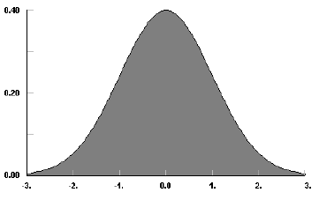

Figure 11: Normal distribution sample curve

**Usage:**

* normal(sigma, mean)
* normal(sigma): mean is assumed to be 0
* normal(): sigma is 1, mean is 0

#### Logistic

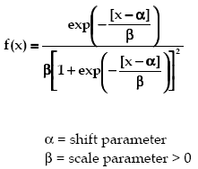

The Logistic distribution is an unbounded continuous distribution which is symmetrical about its mean [and shift parameter], alpha. The shape of the Logistic distribution is very much like the Normal distribution, except that the Logistic distribution has broader tails.   
  
The Logistic function is most often used a growth model: for populations, for weight gain, for business failure, etc. The Logistic distribution can be can be used to test for the suitability of such a model, with transformation to get back to the minimum and maximum values for the Logistic function. Occasionally, the Logistic function is used in place of the Normal function where exceptional cases play a larger role.

**Sample:** beta = 1; alpha =0

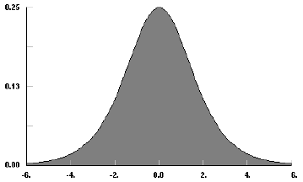

Figure 12: Logistic distribution sample curve

**Usage:**

* logistic(beta, alpha)

#### Uniform

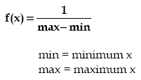

The Uniform distribution is a continuous distribution bounded on both sides, i.e. the sample lays in the interval [min,max). The probability density does not depend on the value of x. It is a special case of the [Beta](http://www.anylogic.com/anylogic/help/topic/com.xj.anylogic.help/html/functions/beta.html) distribution. It is frequently called rectangular distribution.   
The Uniform distribution is used to represent a random variable with constant likelihood of being in any small interval between min and max. Note that the probability of max value is 0; the max point never occurs.

**Sample:** uniform(0,1)

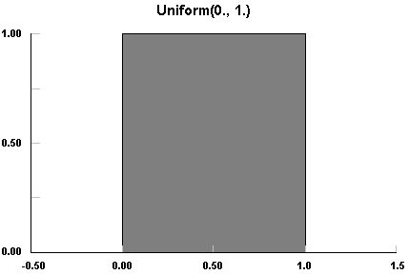

Figure 13: Uniform distribution sample curve

**Usage:**

* uniform(): same as uniform(0,1)
* uniform(max): same as uniform(0,max)
* uniform(min, max)

### Step Distribution

Unlike random distribution the step distribution is not at all random but allocates samples sequentially between the given range of integer value. A step variable can be given to jump particular number of integers. After sample count is overflowed the sample value is again set to min.

**Sample:** step(1,7,2)

Figure 14: Normal distribution sample curve: The chart shows the sampled value after each sample count on x-axis

**Usage:**

* step(min, max, step): Allocates samples sequentially between and inclusive of min and max values and next sample is always current sample + the step value. Therefore it can result in exclusion of max value if the addition of step value to the penultimate sample results in overflow.
* step(min, max):Uses default step as 1.
* step(max):Uses default min as 1 and default step as 1.

### Model Execution and Output Saving

#### Model Execution

This is the stage where it performs all the manipulation of symbols values that the user has entered in the GUI. The complete process is detailed in figure 15. Model parser is essentially supplied two things. One, list of tracked symbols that were changed by user. Second, input test cases created during input modeling. At the end of model execution, Model Parser creates a new ‘Mosel’ file, whose contents will be written on the basis of the original ‘Mosel’ file according to the input test case. This new ‘Mosel’ file will be the basis for the execution (or, running) of the problem. Below are the steps mentioned for the complete process, with respect to Tokenizing and Symbol Parsing.

* **Parameters Block:** In this part of ‘Mosel’, we tokenize parameters that were changed by user and correspondingly modify their value. So as to say, we change the value that is present on right side of “=“.
* **Declaration Block:** In this, we first start by parsing all the symbols we have matched. There could be a case that a constant (or parameter) is present inside this block and thus it would be handled as we did in Parameters block. As in declaration block, the values of symbol are not yet assigned, so we first collect all the symbols. And then outside the declaration block, we assign all the values given from GUI. The values from GUI can also come from external source, for which we write initialization blocks. And thus for this purpose, we do a grouping logic where we group symbols by their external sources that is putting all symbols in one group that are assigned from same external source. This would save us from writing multiple initialization blocks. The  external source we consider in the model are: text, dat, excel and csv. After this, we assign values to all other symbols, taking into account syntax for initialization of arrays and singular ordinary variables. We also keep track of any other initialization done for the symbols we are tracking, these could also be present inside initialization blocks.

#### Output Saving

After a new ‘Mosel’ file was created, it is compiled and executed. After successfully running the new ‘Mosel’, the parser will return list of output symbols along with their values to be shown to the user. Here we save the result of each test case in memory using HashMap. Finally at the end, results of all test cases are written to the excel sheet.

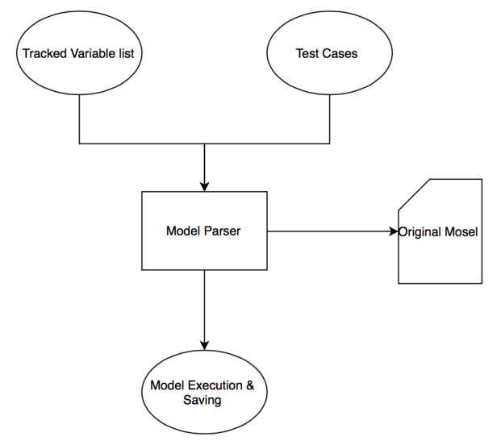

Figure 15: Flow chart for ‘Mosel’ Parser and Executor

### Chart Visualization Modeling

The framework provides four types of chart visualization:

* Line Chart
* Bar Chart
* Scatter Plot
* Pie Chart

The charts are implemented using Apache POI[3] and jFreeChart API[4]. We use Apache POI API for reading and writing data to excel from FEAORA framework. In addition to that, it also support visualization of Line Charts and Bar Charts only. The charts are saved in the excel sheet, along with the values on X and Y axis. As mentioned, apache POI provide in-built support for Line Chart and Scatter Plot only, so as to say that these charts are created programmatically, the same way a user would create it using excel. This way the user will be able to filter corresponding rows and the chart would change itself accordingly. For Bar Chart and Pie Chart charting, we use jFreeChart library, that gives us the functionality of creating an image of the created charts. This snapshot that was created is then written to excel using Apache POI. So, with these two charts, user will not be able to filter but would have to use the application GUI for additional support. The modeling process is further explained in Figure 16.

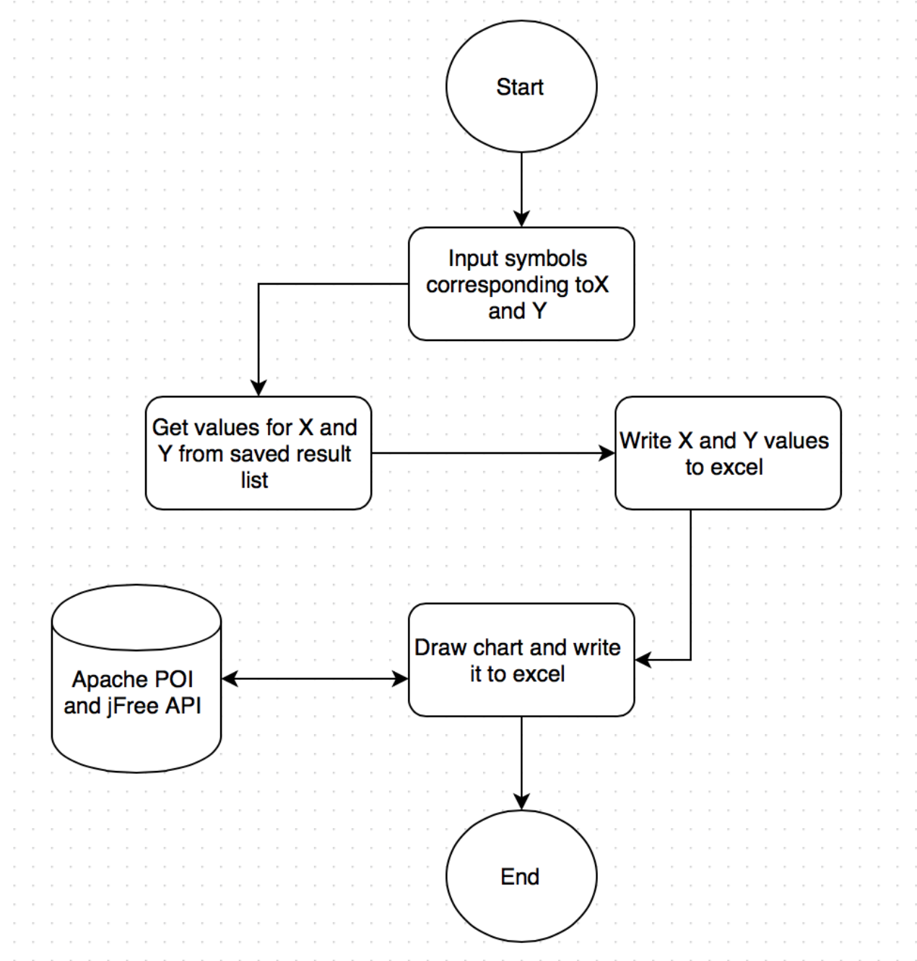

Figure 16: Flow chart for chart visualization

### Map Visualization Modeling

The map visualization are implemented using Google map APIs. The geographical coordinates of a location are retrieved using Google Geocoder API. Geocoder API takes the textual address and returns the coordinates containing longitude and latitude information. This information can be used to mark points in the google map view. These points are marked with initial character in their textual representation and a complete label can be seen on hovering the mouse over the markers or clicking the markers. This feature requires active Internet connection. Figure 17 shows the flow chart for the Google map visualization.

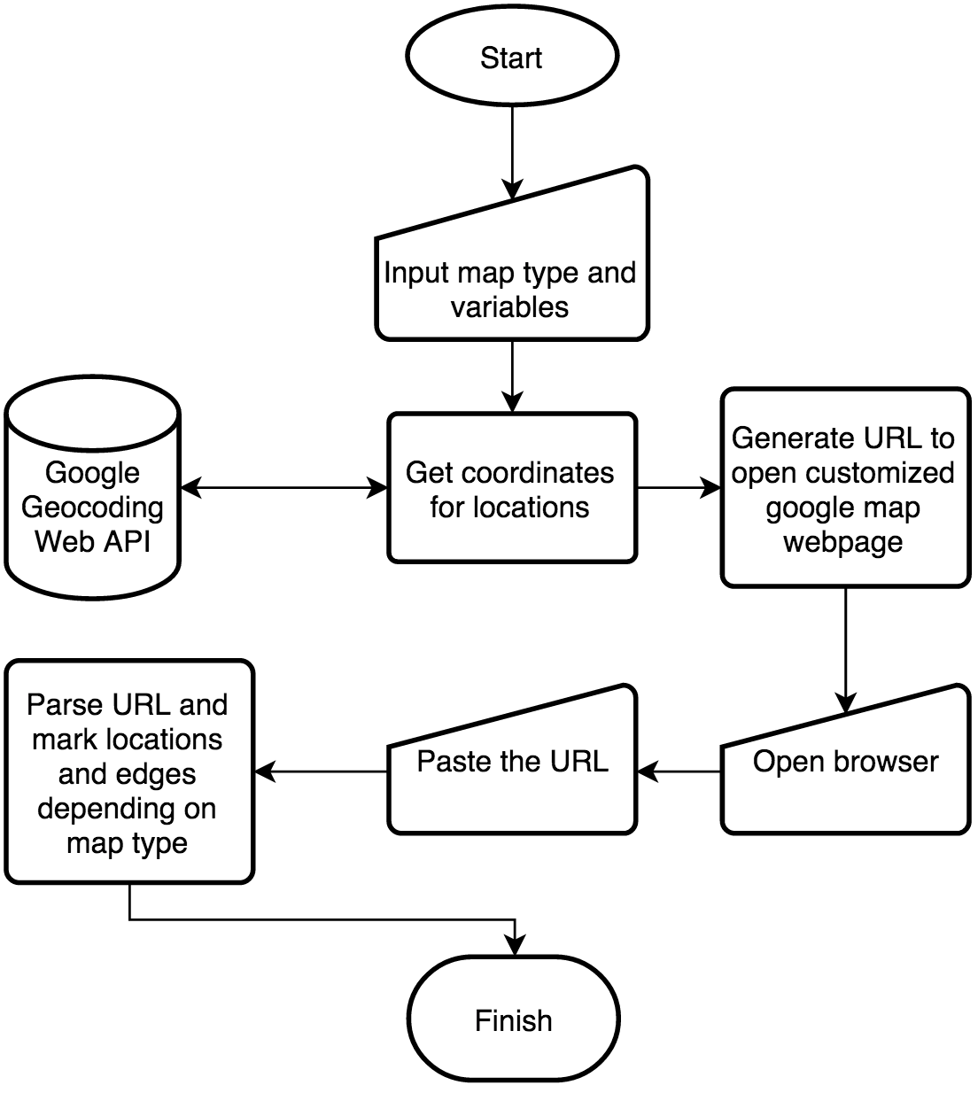

Figure 17: Flow chart for Google map visualization

Currently implemented tool contains two kinds of maps:

1. **Points Only:** Only show markers for selected points based on a 1-dimensional decision array.
2. **Points with paths:** In addition to markers this type also shows links or edges between two markers based on a 2-dimensional decision array.
3. **Points with directed paths:** This variation allows the edges to have direction attribute from a row to a column location in the 2-dimensional array.

The Google Map visualization was initially designed to be embedded in the main application only but due to limitation and slow response in case of zooming and dragging, this feature has been moved to load map in external web browsers installed on the computer hosting the FEAORA framework tool.

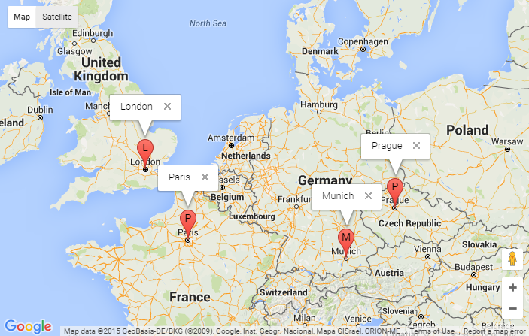

Figure 18: Google map visualization with points only map type

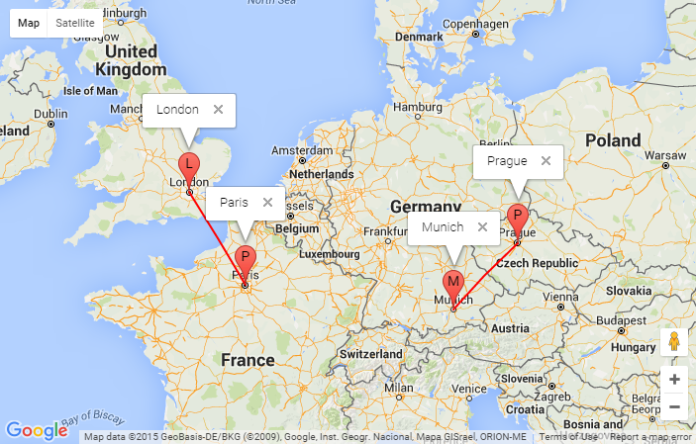

Figure 19: Google map visualization with points with paths map type

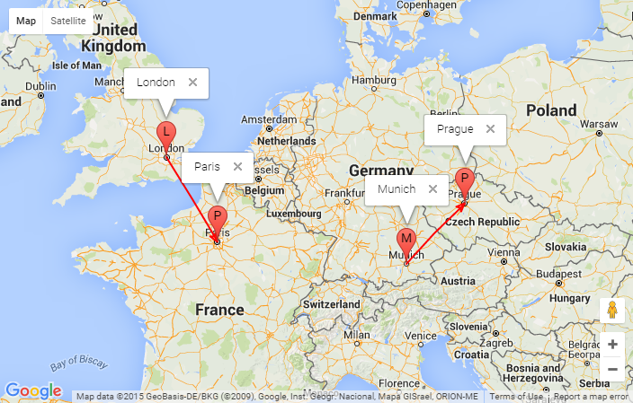

Figure 20: Google map visualization with points with directed paths map type

# Results

The results of the sample case study are presented below.

## Sample ‘Mosel’ Code

This section provides sample ‘‘Mosel’’ code involving a knapsack problem and some code for demonstrating map visualization.

model Burglar11

uses "mmxprs"

declarations

SIZE = 10

WTMAX = 100 ! Maximum weight allowed

ITEMS = 1..SIZE

VALUE: array(ITEMS) of real ! Value of items

WEIGHT: array(ITEMS) of real ! Weight of items

MaxVal: linctr

Depots = {"Delhi","Mumbai","Munich"}

! decision variable which depots have been selected

NodeCondition: array(Depots) of integer

! decision variable which paths have been selected

EdgeCondition: array(Depots,Depots) of integer

end-declarations

declarations

take: array(ITEMS) of mpvar ! 1 if we take item i; 0 otherwise

end-declarations

! just for displaying map usage

NodeCondition::(["Delhi","Mumbai","Munich"])[0,1,1]

EdgeCondition::[0,1,1,0,0,0,0,1,0]

! Objective: maximize total value

MaxVal:= sum(i in ITEMS) VALUE(i)*take(i)

! Weight restriction

sum(i in ITEMS) WEIGHT(i)*take(i) <= WTMAX

! All variables are 0/1

forall(i in ITEMS) take(i) is_binary

maximize(MaxVal) ! Solve the MIP-problem

! Print out the solution

writeln("Solution:")

forall(i in ITEMS) writeln(" take(", i, "): ", getsol(take(i)))

! Output solution to calling application

!initializations to IODRV

! evaluation of getobjval as SOLVAL

! evaluation of round(sum(i in ITEMS) getsol(take(i))) as NUM

!end-initializations

end-model

## Sample Input Configuration

The sample input configuration for the above problem is shown in Figure 21. All the variables are marked for output tracking.

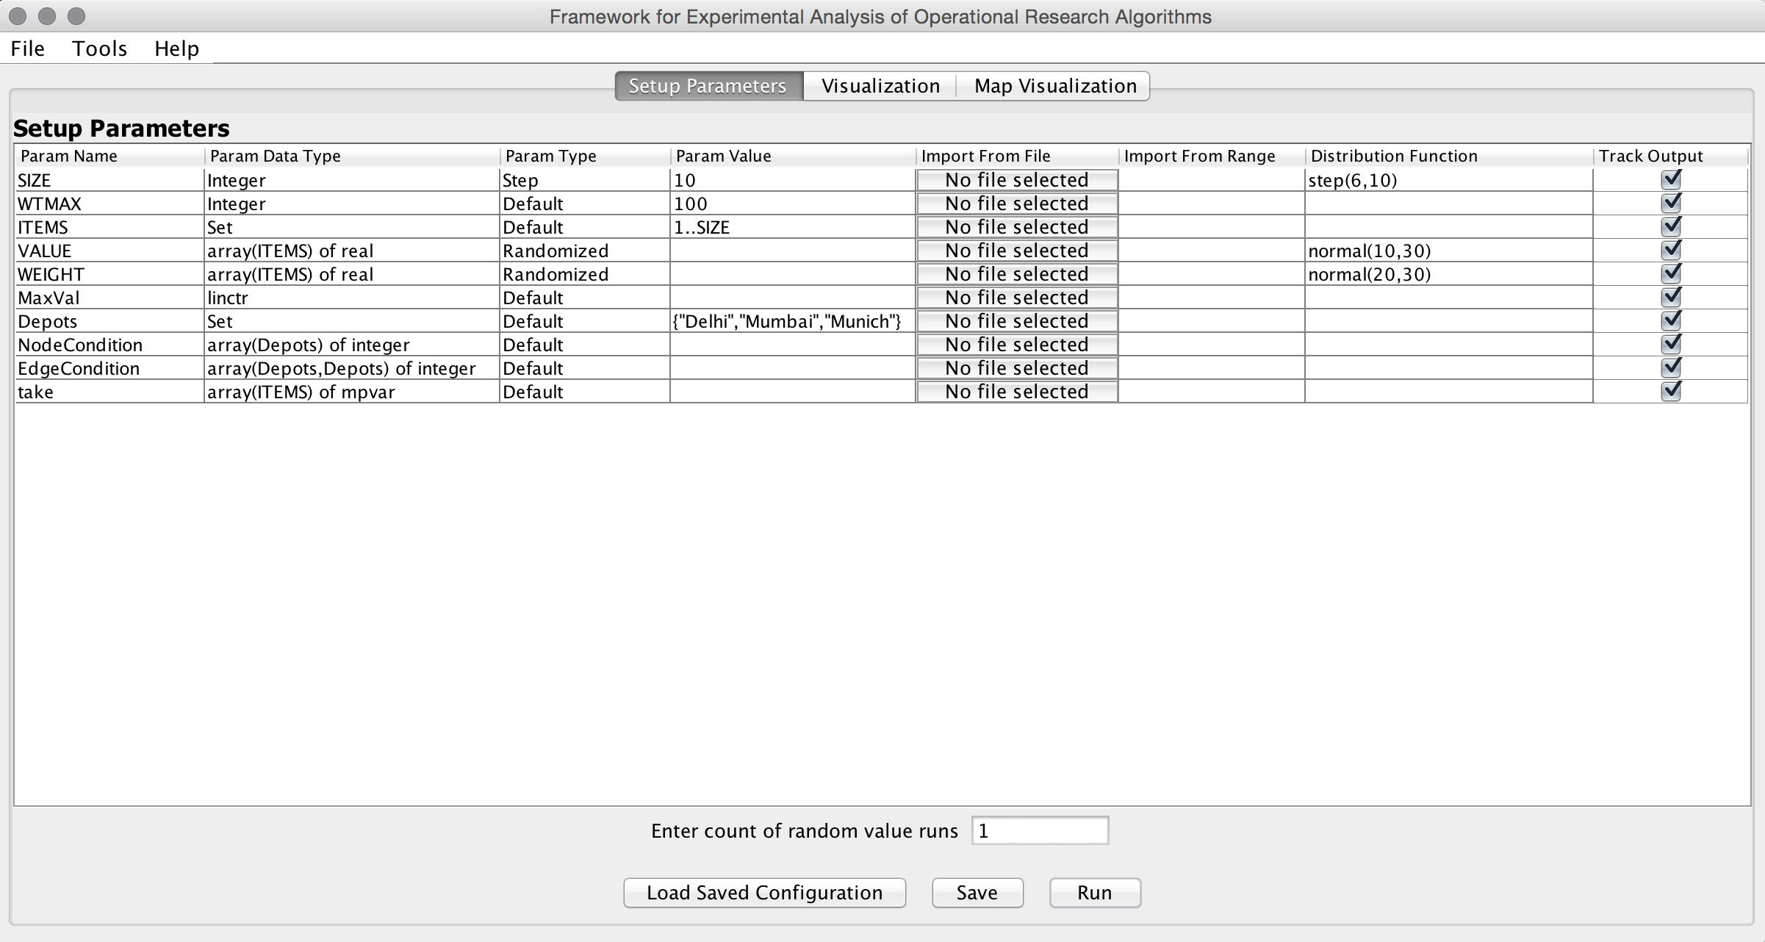

Figure 21: Sample input configuration screen

## Output analysis

The tracked variables of a model execution gets saved in an excel file. User can easily filter or sort the results using excel filtering and sorting functionality. This does not require any additional programming skill from the user. Figure 22 shows the output for the executions.

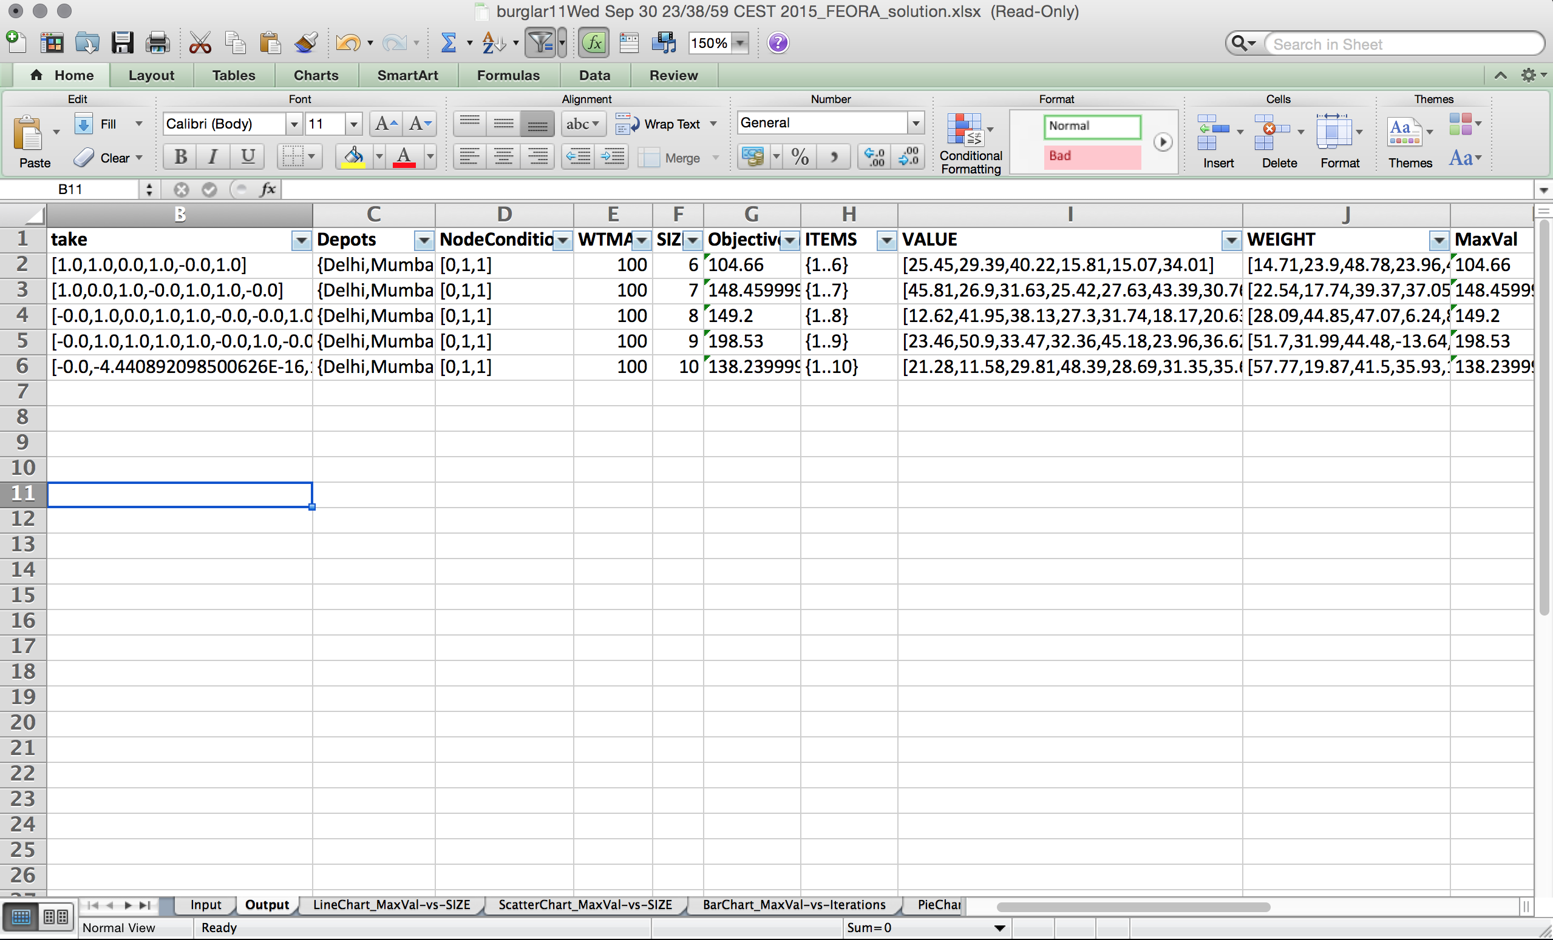

Figure 22: Output saved in excel format

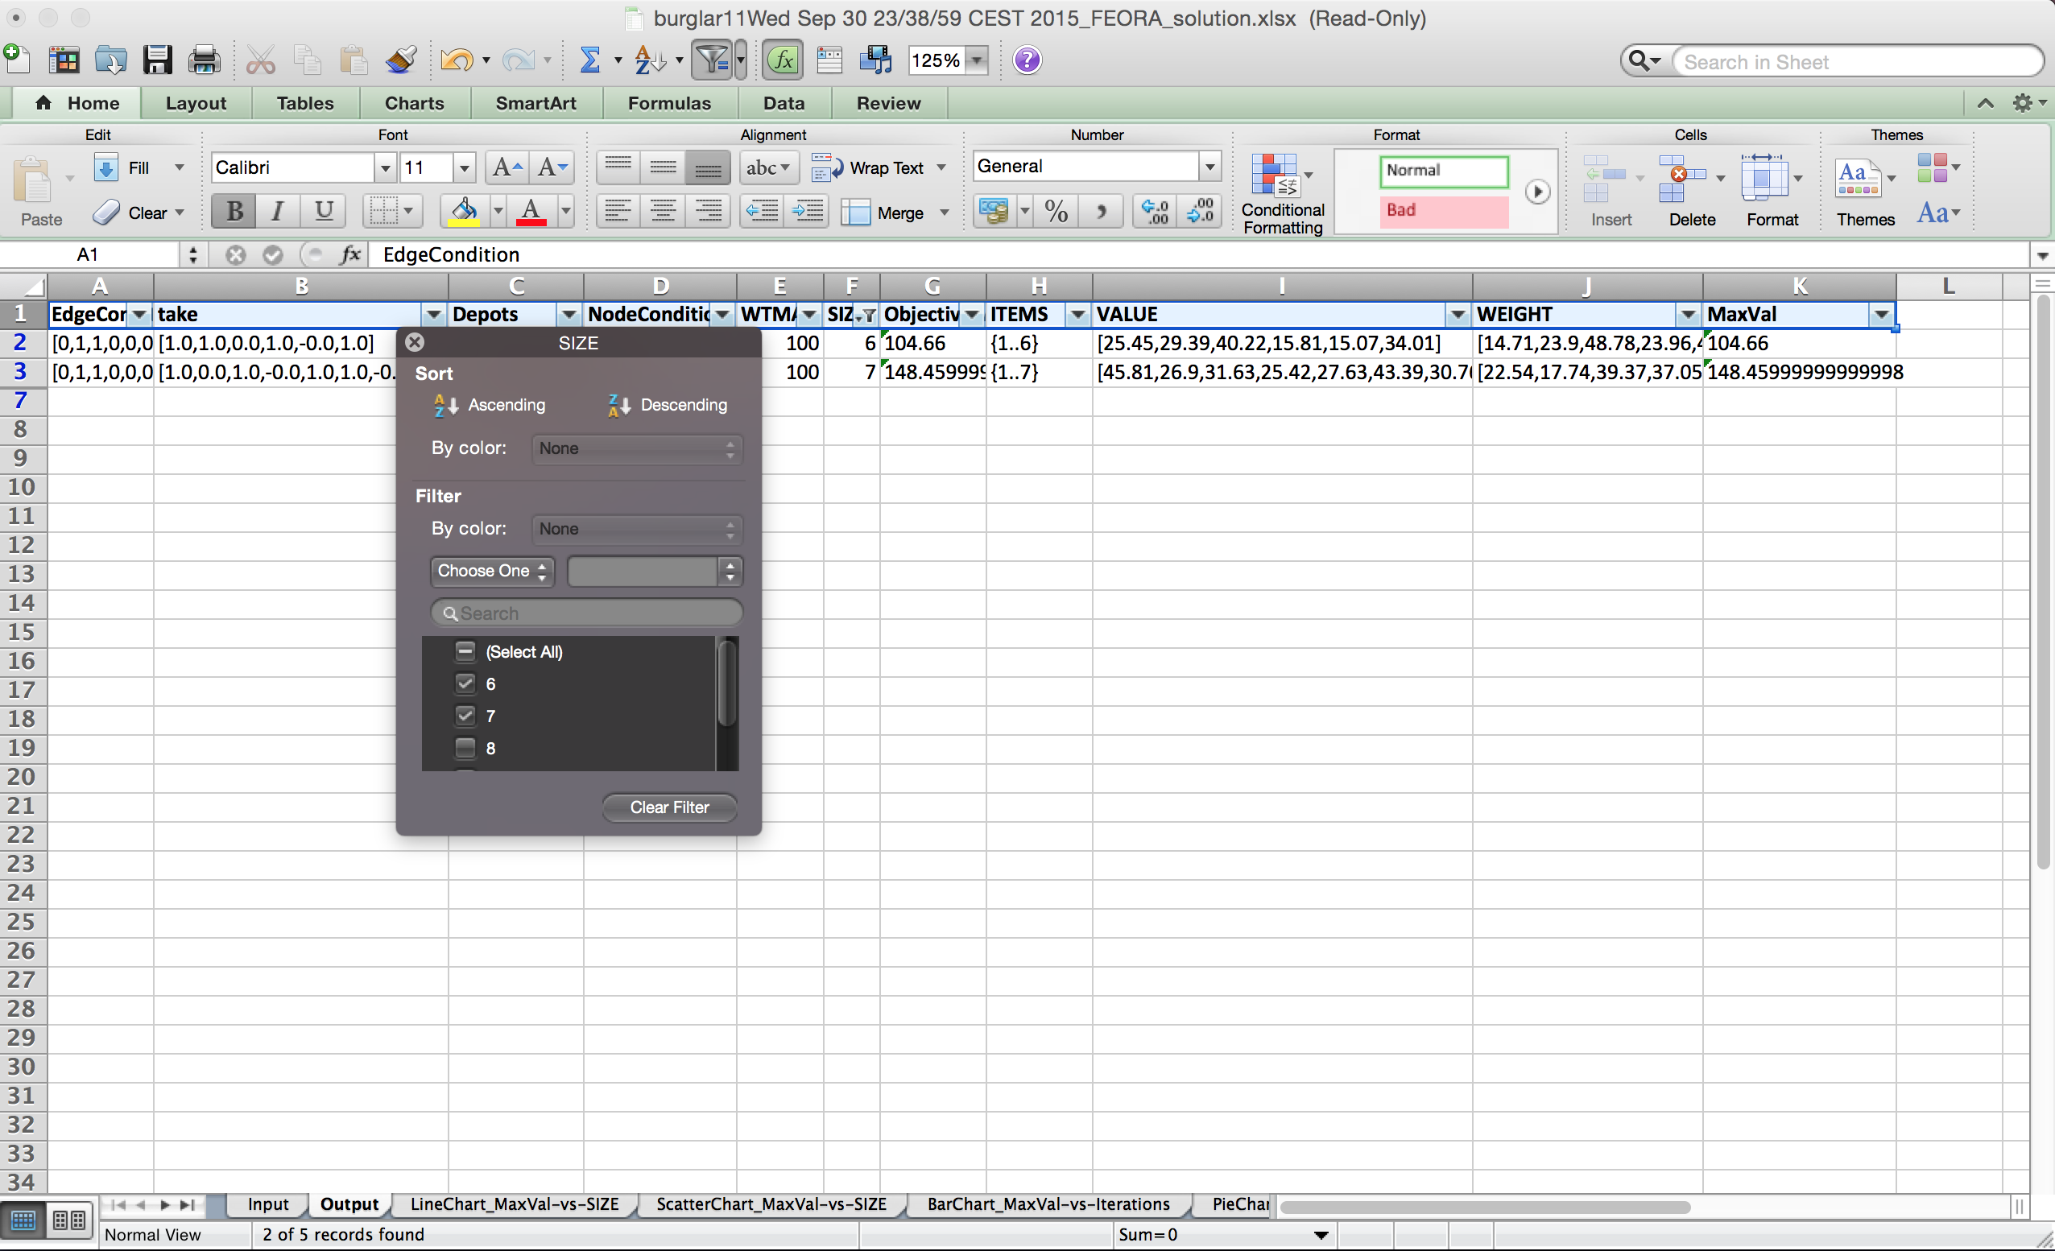

Figure 23: Filtering of the result rows using excel filter option

## Sample Chart Visualization Configuration

The following figure shows the sample chart configuration for this problem.

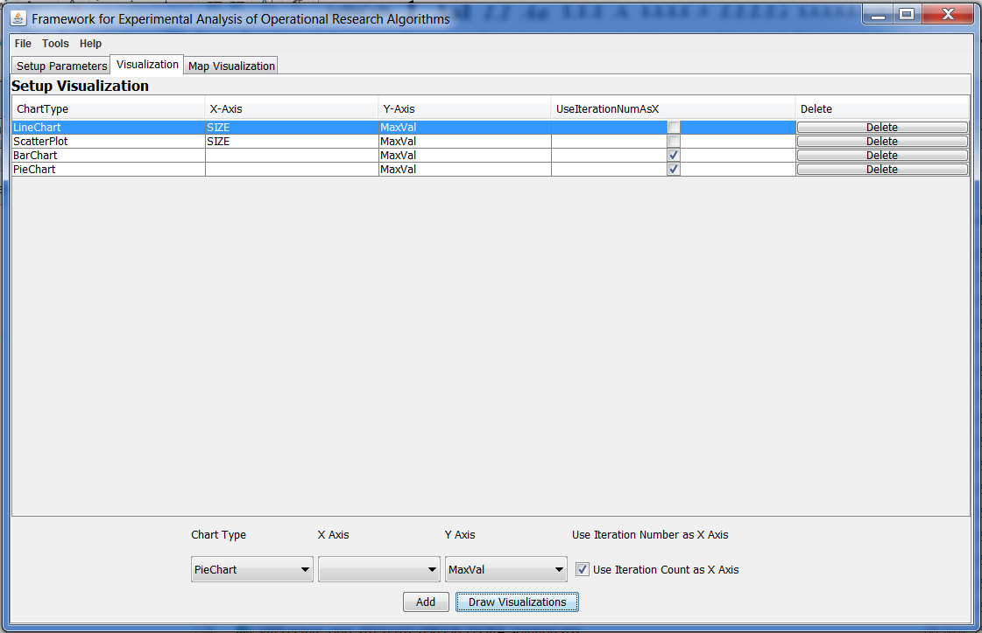

Figure 24: Sample chart visualization configuration

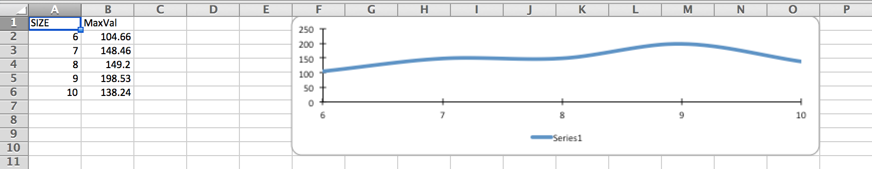

Figure 25: Sample line chart visualization

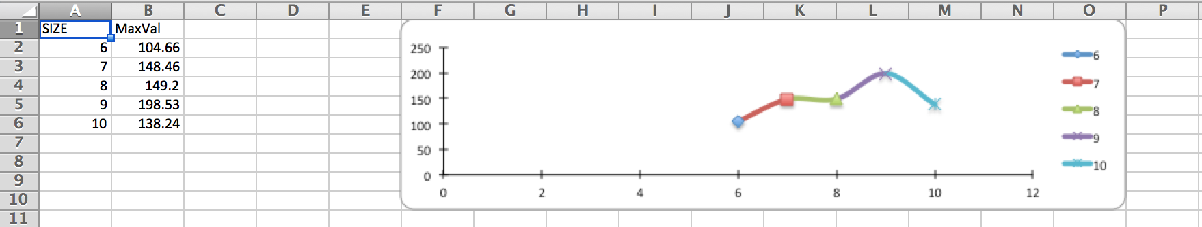

Figure 26: Scatter chart visualization

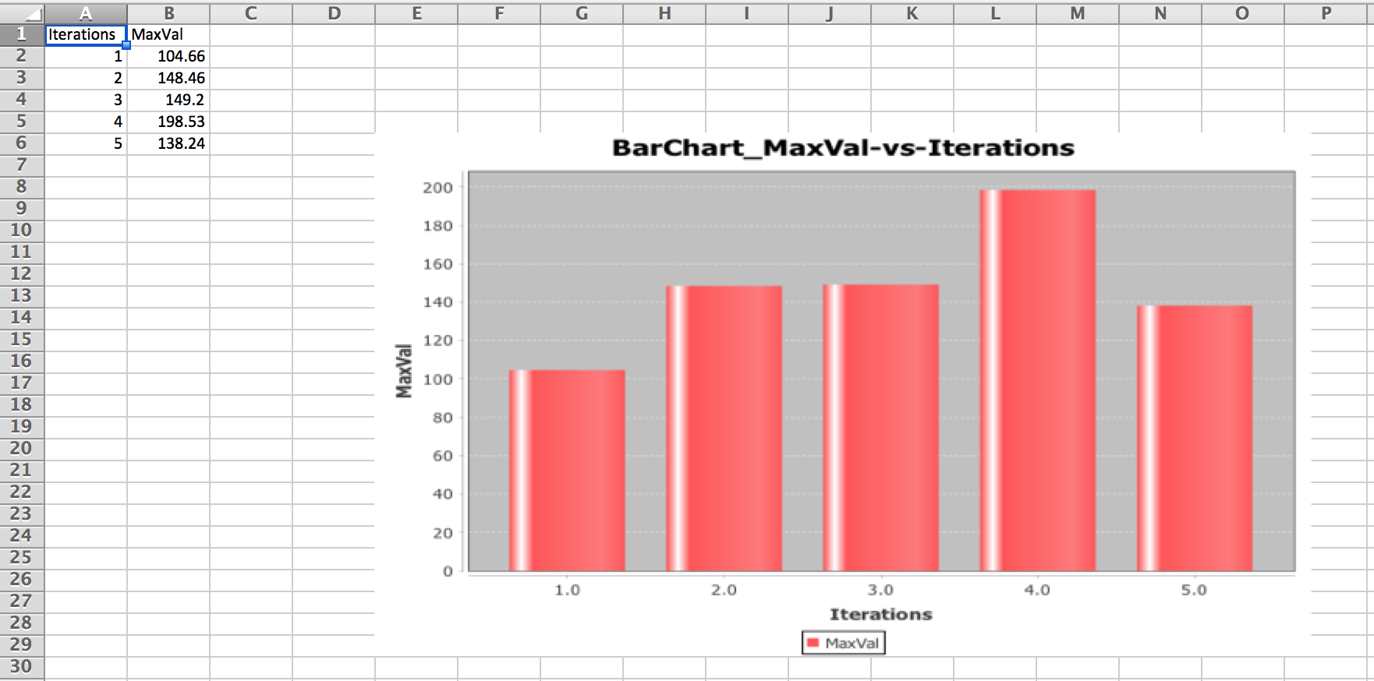

Figure 27: Bar chart visualization

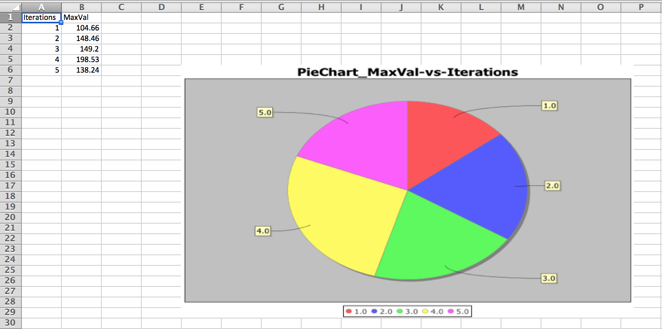

Figure 28: Pie chart visualization

## Sample Map Visualization Configuration

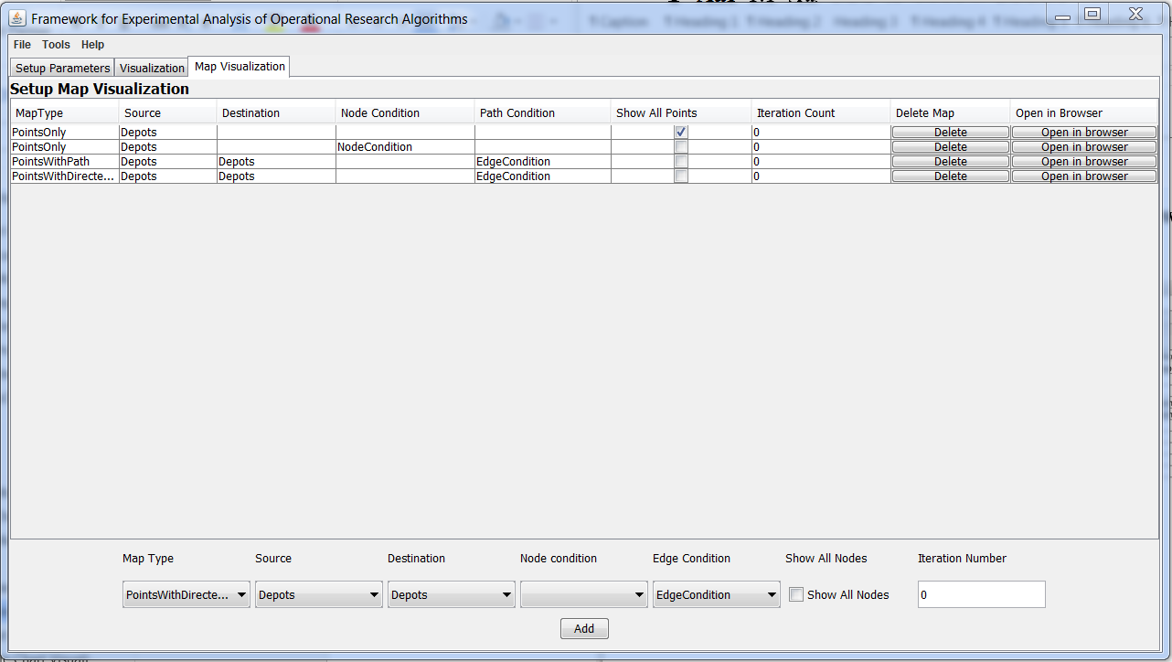

Figure 29: Sample map visualization configuration

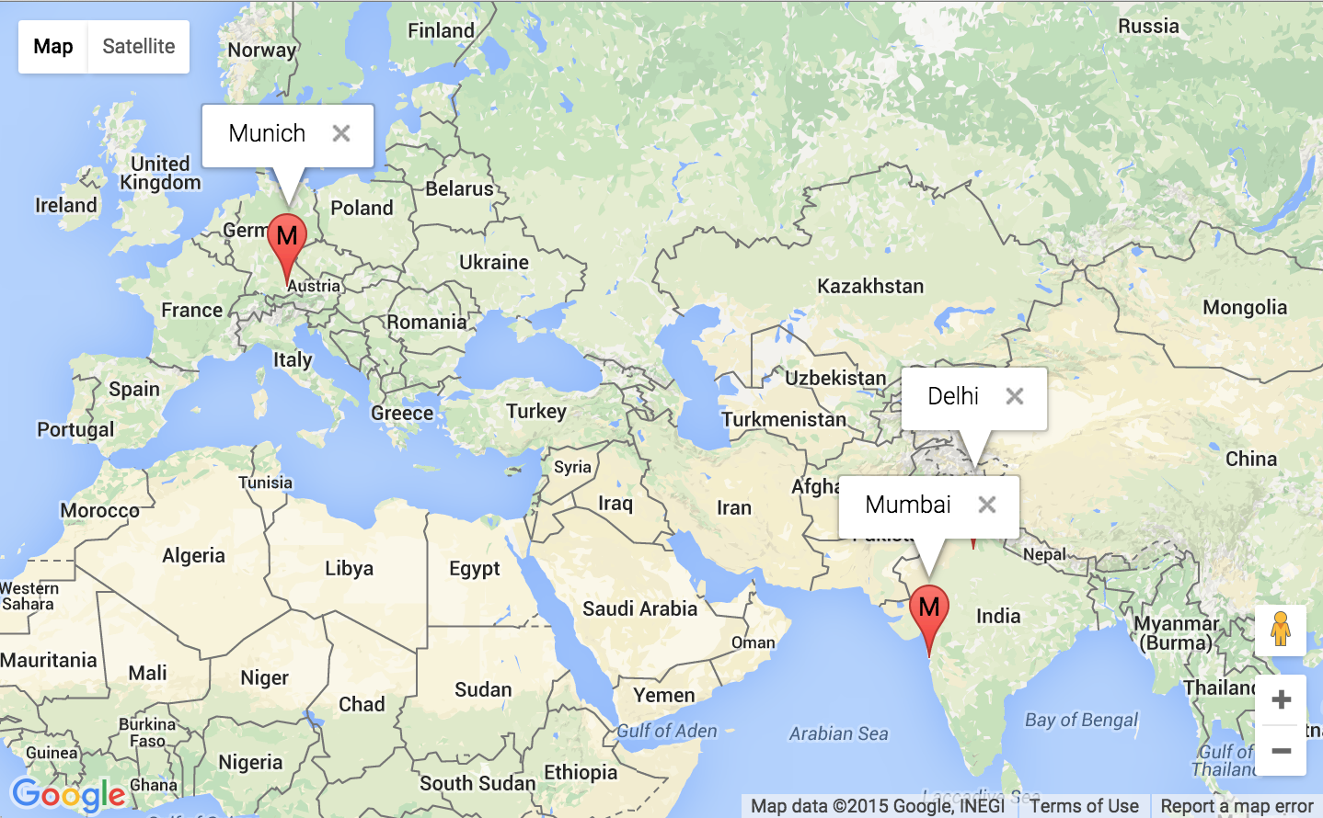

Figure 30: Points only map output with show all nodes option checked

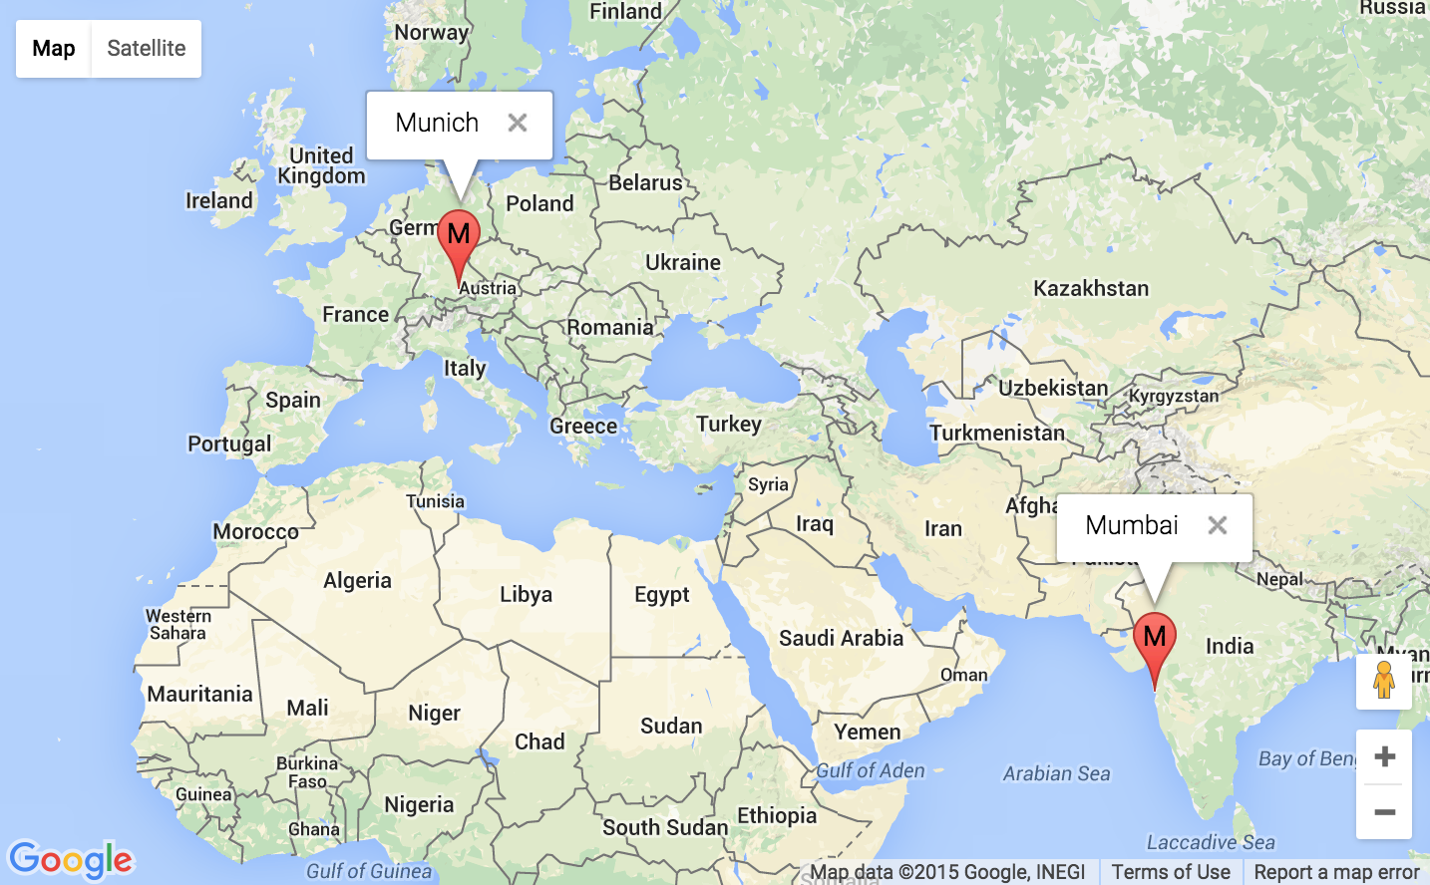

Figure 31: Points only map with filtered points using a 1-D node condition array

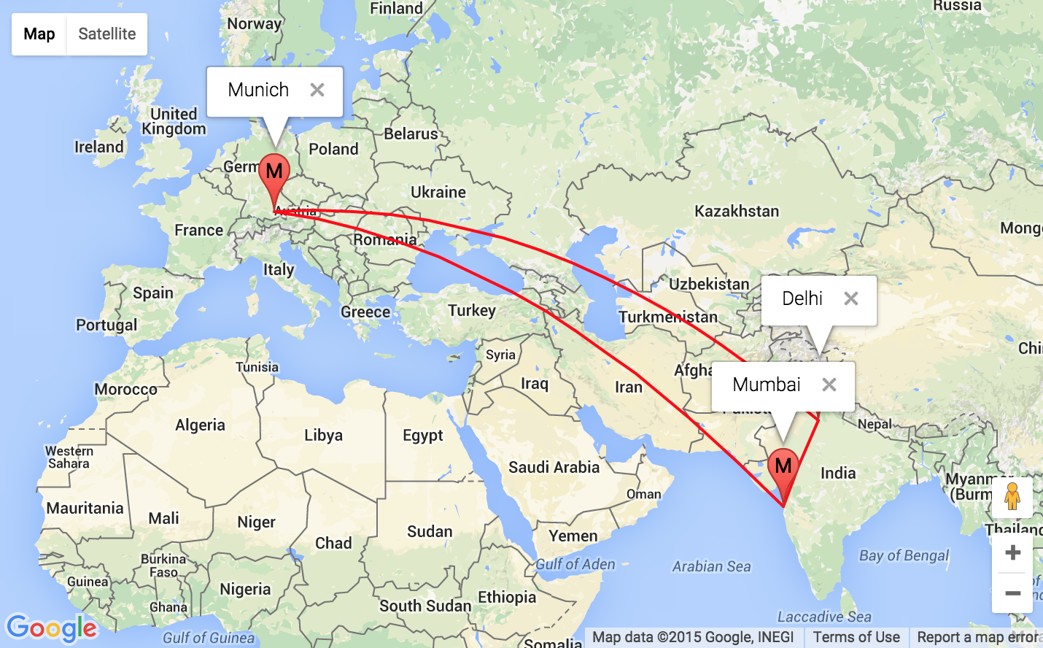

Figure 32: Points with path map with filtered edge using 2-D edge condition array

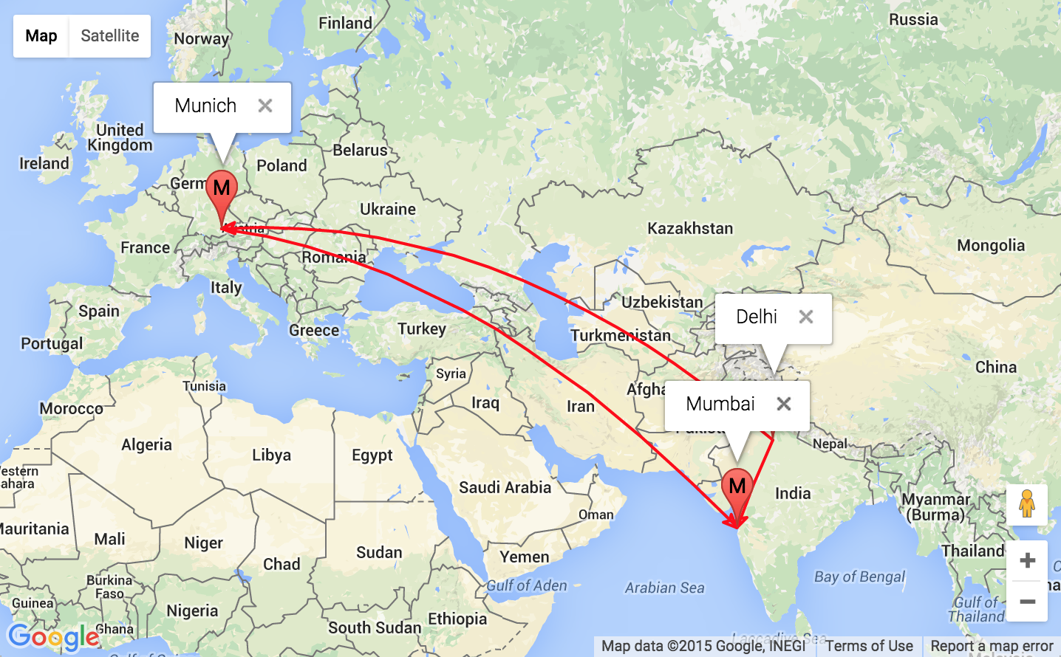

Figure 33: Points with directed paths with filtered edge using 2-D edge condition array

# Conclusion

From the sample study, it was observed that:

* The goals set in the Section 1 of this report were met completely.
* We have a working tool of the framework that allows the user to:
  1. Model input configuration based on manual input, probability distribution, external data file or excel file and step distribution.
  2. Test instance generation based on input configuration and execution of OR algorithm based on different input instances.
  3. Storage of output of OR algorithm in user friendly excel format where user can visually filter the data based on powerful and easy to use excel filtering and sorting.
  4. Output visualization modeling based on some commonly used charts such as line, scatter for complete set of iterations for given variables representing X and Y axis; also Google map visualizations for each iteration are provided for variables set as locations, location showing criteria and path showing criteria.
* Requirements listed in Section 1 are also completely implemented.

## Limitations of the FEAORA framework

The FEAORA framework reduces manual labor for OR scientist but the there are few limitations to current implementation due to time constraints. Following are the few limitations that exist in the tool for the framework:

1. Cannot add new variables from input modeling
2. Cannot use charts to display array
3. Bar and Pie chart are static but user may opt to change line chart to any other kind of chart in excel just by changing the chart type. These charts are not yet fully supported by POI library that is used to create the solution excel file.

## Further Research and Improvement

The above limitations can be worked upon in future by another team or person who is extending the current implementation. Few of the improvements suggested are :

* More probability distributions can be added.
* Also loading of output in the Java application will allow user to see everything in one place.
* More strict validation for user entered data for visualizations can be added.
* Saving of chart and map configuration to excel to reuse them in future.

# Bibliography

[1] Jan Christian Lang, Thomas Widjaja - OREX-J: towards a universal software framework for the experimental analysis of optimization algorithms, OR Spectrum (2013) 35:735–769

[2] Apache Probability Distributions: <http://commons.apache.org/proper/commons-math/userguide/distribution.html>

[3] Apache POI - the Java API for Microsoft Documents

<https://poi.apache.org/>

[4] JFreeCharts

<http://www.jfree.org/jfreechart/>

[5] Anylogic Help for Probability distributions

<http://www.anylogic.com/anylogic/help/>

[6] Xpress ‘Mosel’ User Guide

[http://www.fico.com/en/wp-content/secure_upload/Xpress-’Mosel’-User-Guide.pdf](http://www.fico.com/en/wp-content/secure_upload/Xpress-Mosel-User-Guide.pdf)

[7] FICO Xpress Optimization Suite

<http://www.fico.com/en/products/fico-xpress-optimization-suite>

Ehrenwörtliche Erklärung

Ich erkläre hiermit ehrenwörtlich, dass ich die vorliegende Arbeit selbständig angefertigt habe. Die aus fremden Quellen direkt und indirekt übernommenen Gedanken sind als solche kenntlich gemacht.

Ich weiß, dass die Arbeit in digitalisierter Form daraufhin überprüft werden kann, ob unerlaubte Hilfsmittel verwendet wurden und ob es sich – insgesamt oder in Teilen – um ein Plagiat handelt. Zum Vergleich meiner Arbeit mit existierenden Quellen darf sie in eine Datenbank eingestellt werden und nach der Überprüfung zum Vergleich mit künftig eingehenden Arbeiten dort verbleiben. Weitere Vervielfältigungs- und Verwertungsrechte werden dadurch nicht eingeräumt.

Die Arbeit wurde weder einer anderen Prüfungsbehörde vorgelegt noch veröffentlicht.

München, den 12.11.2015

Anshul Vij Akshit Malhotra